🔹 V8 engine
--------------
Role in Node.js:

Compiles JavaScript into native machine code.

Executes your application’s JavaScript code.

Provides runtime environment for JavaScript features like Promise, async/await, JSON, etc.

Key point:

Think of V8 as the brain of Node.js — it runs your JS code.

🔹 libuv
------------

What it is:

A multi-platform support library focused on asynchronous I/O, Written in C.

Role in Node.js:

Handles the event loop.

Provides non-blocking I/O via thread pool.

Deals with:

File system operations (fs)

Networking (sockets, DNS, HTTP, etc.)

Timers (setTimeout, setInterval)

Child processes

Key point:

Think of libuv as the heart + muscles of Node.js — it powers async operations and event-driven architecture.

⚡ How they work together in Node.js:

# Your JS code runs inside V8.
# When JS calls something like fs.readFile() or setTimeout(), it’s handed off to libuv.
# libuv runs the operation asynchronously (in background threads or via OS).
# When the operation finishes, libuv pushes a callback back into the event loop.
# V8 executes the callback in your JavaScript code.

✅ Analogy

# V8 = The interpreter/engineer → understands and runs JavaScript.

# libuv = The worker manager → handles all async tasks, file I/O, and networking.

# Without V8, Node.js wouldn’t run JavaScript.
# Without libuv, Node.js wouldn’t be asynchronous.

Process, Thread, Thread Pool:
---------------------------------

🔹 1. Process:

A process is an instance of a program running on your system.
Each process has:
Its own memory space (heap, stack, data, code).
At least one thread (usually the main thread).
Example:
If you run node app.js, that starts one Node.js process.

🔹 2. Thread( Single/Main Thread):

A thread is the smallest unit of execution inside a process. OR It's sequence of instractions.

Example:
A browser process may have multiple threads:

# UI thread
# Network thread
# JS execution thread (V8)

🔹 3. Thread Pool
A thread pool is a group of pre-created threads that are reused to perform tasks.
Instead of creating/destroying threads each time (expensive), tasks are queued, and threads pick them up.
Examples of operations that go into libuv’s thread pool:
#File system operations (fs.readFile, fs.writeFile)
#DNS lookups (dns.lookup)
#Compression (zlib, crypto)
#Some networking tasks

🔹 How They Relate in Node.js

#Process: The Node.js instance (node app.js).

#Main thread: Runs your JS code in V8 (single-threaded).

#Thread pool (libuv): Handles async tasks that V8 delegates.

👉 Flow:

#Your JS code (setTimeout, fs.readFile) runs in the main thread.

#Async tasks (like file I/O) go to the libuv thread pool.

#Once done, callbacks are pushed into the event loop.

#The main thread picks them up and executes in V8.

✅ Analogy

#Process = A restaurant.

#Threads = Waiters inside the restaurant.

#Thread pool = A fixed team of waiters that serve tasks (customers) in rotation.

👉 Working Flow of Nodejs Code:
--------------------------------
Initialize programm -> Executes "top-level" code -> require modules -> Registers events callback -> Starts Event loop -> Now event loop offloads heavy
task(Blocking in nature like DB, files operations etc) to Thread Pool to avoid event block and perform asynchronously.

👉 Event Loop:
----------------
JavaScript runs in one thread → it can only do one thing at a time.
If you ask it to read a big file or wait 5 seconds, everything would freeze.
The event loop + libuv solve this by delegating heavy/async tasks away, and only running callbacks when results are ready.

🟢 How It Works (Simplified Steps)

Call stack: Runs your JS code line by line.

If it sees async stuff (setTimeout, fs.readFile), it gives it to libuv.

libuv does the work in the background.

When ready, it puts the callback into a queue.

The event loop checks:

"Is the stack empty?" → Yes → take next callback from the queue → run it.

Repeat forever 🔄

🟢 Example
console.log("A");

setTimeout(() => {
console.log("B");
}, 0);

console.log("C");

👉 Output:
A
C
B

Why?

"A" → runs immediately.

setTimeout → goes to libuv → callback saved for later.

"C" → runs immediately.

Event loop comes back → runs "B".

Event Driven Architecture of Event Loop :
When we starts our application, events loops starts running right away, event loop has multiple phases, each phase have callback queue.

👉 Events are emitted.
👉 Event loops picks them up
👉 callbacks are called:

Here are 4 important callbacks queue:

1.Expired Timer callback: it take cares callback from expired timer
setTimeout(()=>{ console.log('Timer Expired') });
2. I/O Polling ( looking for new i/o event to process and putting them into callback )
and callback.
i/o means networking, file accessing, Example:
fs.readFile('file.txt',(e, d)=>{ console.log('File Rad!'); })
3. SetImmediate callback: specail timer, can be used to to processes callback immediately after the I/O Polling or execution phase.
4. Close callback: all close events are processes.

Other Than this 4 callback queue, there are Two more process.nextTick() and Microtask queue.
Mainly use for resolving promises. Here too, processesnextTick() is used when we really want somewthing to execute right after current event, OR can say , Runs immediately after the current function finishes, before any other microtasks or event loop phases, its Priority is higher than Promises.
Example:
console.log("A");

process.nextTick(() => {
console.log("B - nextTick");
});

console.log("C");
👉 Output:
A
C
B – nextTick

While Microtask Queue are Executed after all process.nextTick() callbacks, but still before event loop continues.

console.log("A");

Promise.resolve().then(() => {
console.log("B - promise");
});

console.log("C");

👉 Output:
A
C
B - promise

Together:

console.log("A");

process.nextTick(() => {
console.log("B - nextTick");
});

Promise.resolve().then(() => {
console.log("C - promise");
});

console.log("D");

👉 Output:

A
D
B - nextTick
C – promise

✅ Key Difference
- process.nextTick(): Runs before Promises, immediately after the current operation finishes.
- Promise (microtask): Runs right after all process.nextTick() are done.
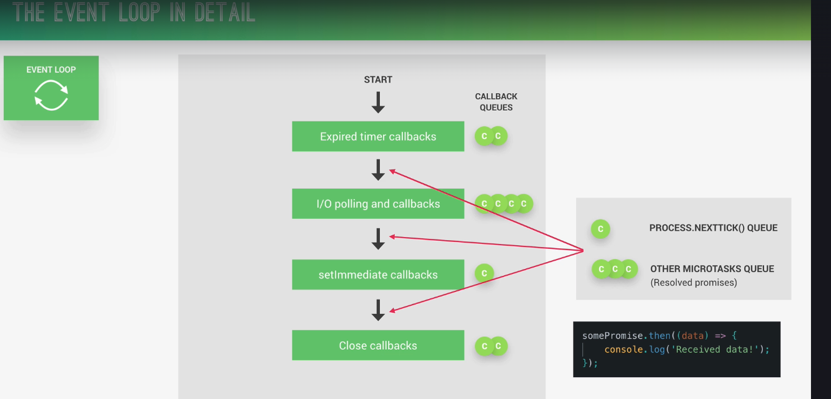

How event loop goes on ? At last Event loop checks for pending timers or I/O tasks , if any left then it agains runs the loop else exit the program.

